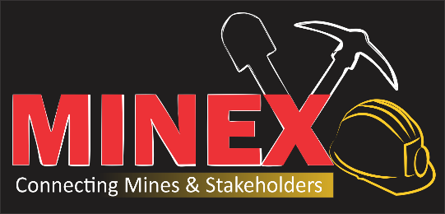

MBERENGWA MINEX REPORT
31 OCTOBER 2019
EDUCATION HALL

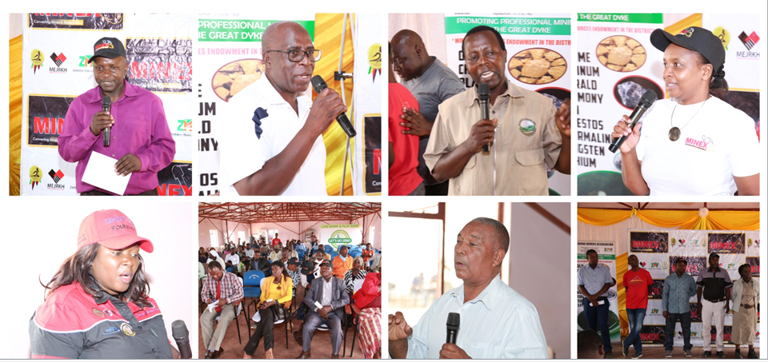

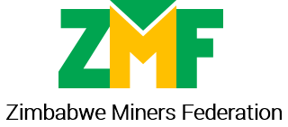

- Who attended?
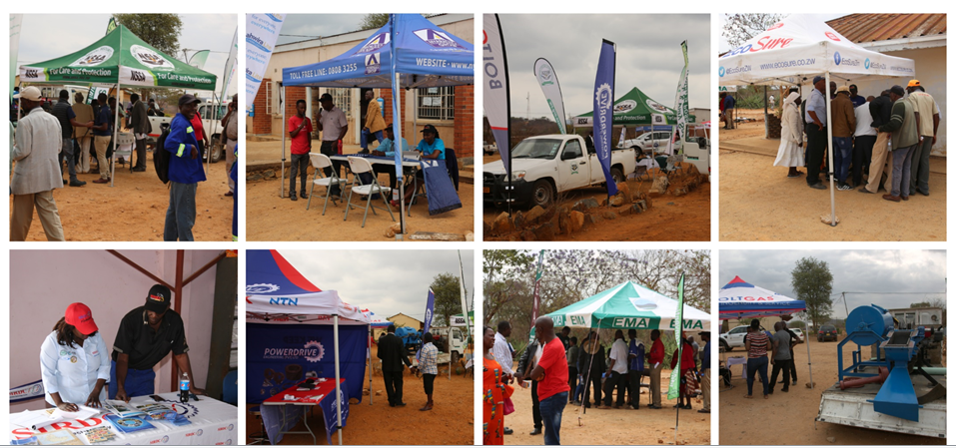
Mining stakeholders | Partners | Exhibitors
Mberengwa Rural District Council | National Social Security Authority (NSSA)  {Silver Partner} | Mimosa Mining Company
District Administrator | Golden Reef Mining  {Meal Partner} | Nyaradzo Funeral Services
Reserve Bank of Zimbabwe | Boltgas  {Anchor Exhibitor} | Scientific and Industrial Research and Development Centre ( SIRDC)
Environmental Management Agency (EMA) | YAFM  {Media Partner} | Power drive
Zimbabwe Miners Federation (ZMF) Executive and membership | Mimosa Mining Company | Econet
Ministry of Lands Agriculture, Climate Water and Rural Resettlement |  | EMA
Print and electronic media |  | NSSA
150 Small Scale Miners |  | Boltgas

- Highlights from presentations and discussions
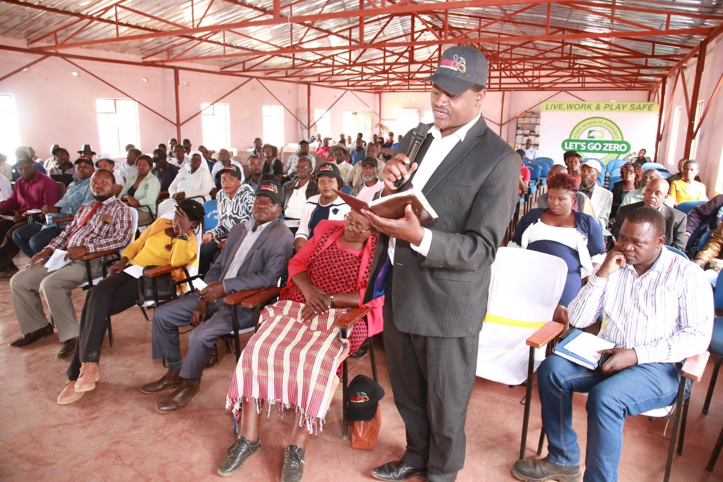
Regulatory issues
- Small-scale miners were reminded that the land belongs to the RDC and they are to pay their licence fees which are only $20 per year. The RDC representative said the majority were not paying.
- The DA’s office is available to coordinate all critical stakeholders for mining activities to go on smoothly
- EMA were applauded for the simpler Environmental Management Plan (EMP) requirement that replaced the Environmental Impact Assessment (EIA)
- High costs of electricity and fuel were said to be hindering production and small scale miners appealed for Government support.
- High costs of electricity and fuel were said to be hindering production and small scale miners appealed for Government support.

Finance
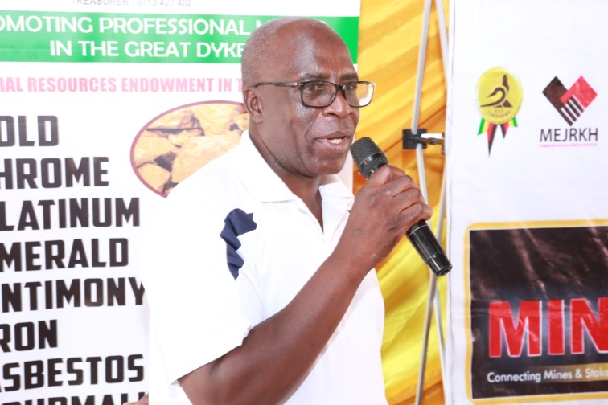
- In Zimbabwe mining contributes more than 60% of foreign currency generation. Up to 18 October 2019, the country received US2.2 billion from mining, down from US2.5 billion in the same period last year.
- Gold deliveries to Fidelity have gone down significantly. The Ministry of Mines and Mining Development’s target for gold deliveries was 40 tonnes for 2019, by end of September we achieved only 20.6 tonnes and of that 13 tonnes came from small scale miners. Last year at the same time deliveries were on 28 tonnes, small scale miners having achieved 19tonnes.
- US1.2 billion was achieved from gold by 18 October 2018, in 2019 we have achieved US866 million for the same period.
- The Gold Development initiative which was at $80 million last year, was increased to $150 million at the beginning of 2019 , then to $200million in June/July 2019.
- There is a lot of indiscipline in paying back the Gold Development Initiative funds by small-scale miners.
- Small-scale miners are not happy with the 45%:55% retention rate when selling gold and believe this is the major reason gold deliveries are going down. Small-scale miners prefer the 20%:80% retention rate that had earlier been proposed. There were also calls for the RTGS component to come as hard cash.
- RBZ encouraged small-scale miners to embrace financial inclusion through opening bank accounts as well as making use of plastic money.
- Very few miners from Mberengwa benefited from the Gold Development Initiative. Of the miners present only 5 applied, 1 got the loan, 1 got a response and 3 did not even get a response. It was suggested that Fidelity works with miners’ associations in distributing funds under the loan scheme.
- The requirement for a geological report for one to access a loan from the Gold Development Initiative is prohibitive given that one also has to raise collateral. One needs USD400 to get a geological report.
- Miners called on Government to also consider funding support for chrome miners.
Health and Safety

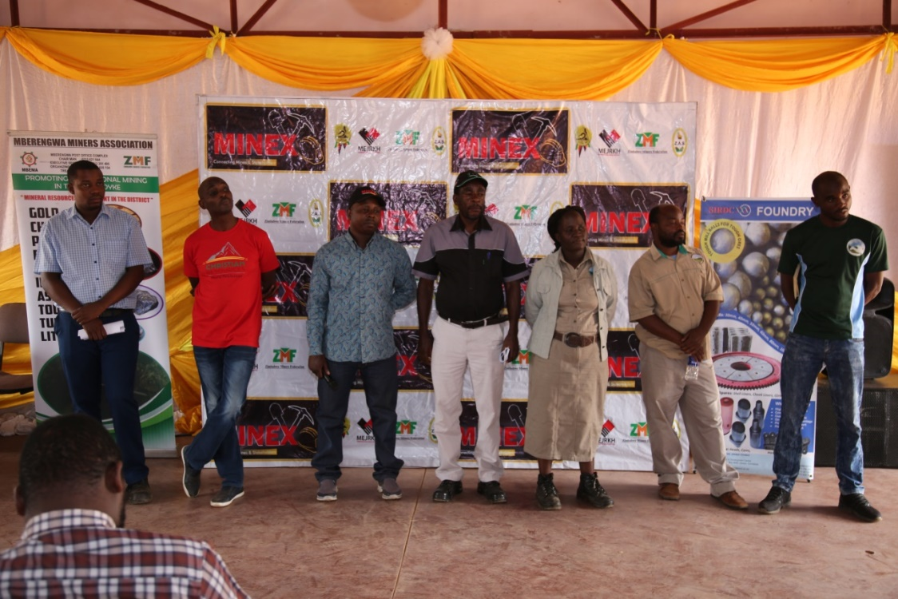
- Miners were discouraged from using mercury in gold processing and educated on safe use of the chemical because of its health risks that include negative effects on unborn babies and low sex drive.
- NSSA has health experts that can assess small-scale miners’ health and educate them on occupational health and safety issues at their places of operation. All miners need to do is to group themselves and invite NSSA.
- Boltgas encouraged the use of concentrators as these are environmentally friendly and one does not need to use mercury
- On mercury alternatives, a suggestion was Borax which is said to be less hazardous than mercury.

Technical and other support
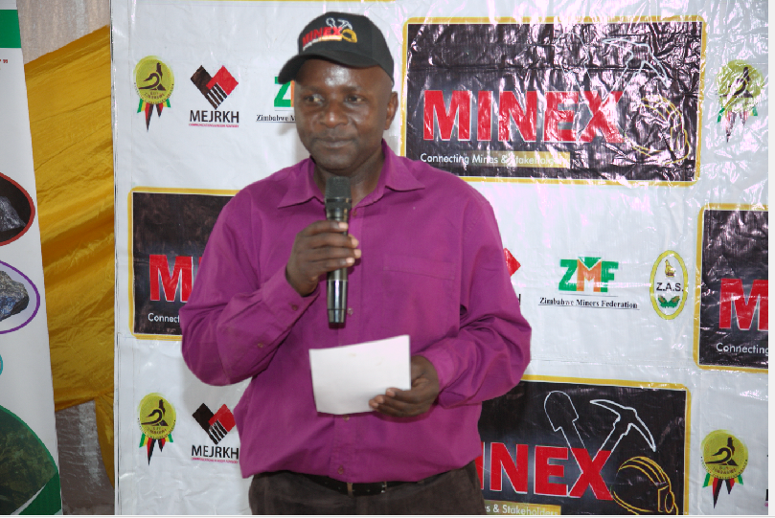
- Golden Reef mining is starting a gold mining project in Mberengwa, will use the heap leaching method which uses ores with very little concentration. The company promised to work with small scale miners to improve technical know-how.
- Boltgas offers a package to small-scale miners that include a hammer mill and jaw crusher and can be upgraded as the mining operation grows.
- Nyaradzo Funeral Services unveiled its 20 group policy for funeral cover with immediate cover.
- Small-scale miners were advised to use certified metal detectors (x-rays) when exploring for gold and where they can afford and where large amounts of investment are involved, follow with other methods such as diamond drilling and RC drilling to establish the actual quantities of minerals.

Mining Technology
- SIRDC advised miners that there is need to make use of ball mills, stamp mills, hammer mills and a variety of spares to ensure quality and sustainable mining.
- It is critical to use the right equipment to ensure quality of output.
- Mining technology enables the process to be quick and effective.
- The stamp mills help to select the appropriate ore.
- SIRDC has a variety of spares, stamp mills for both small and large small- scale miners and they are available at affordable prices in the Harare and Bulawayo branches.

Partners and Exhibitors

